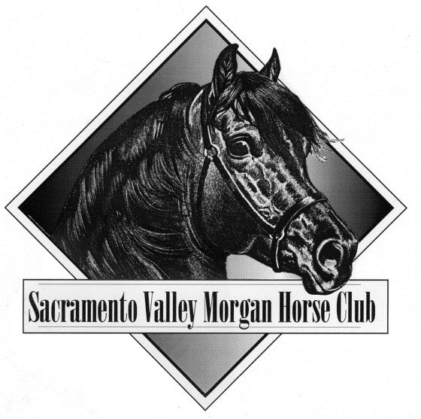
SACRAMENTO VALLEY MORGAN HORSE CLUB
2024 MEMBERSHIP APPLICATION
1-1 TO 12-31
PLEASE COMPLETE THE FORM COMPLETELY

AMHA NO.: ______________ New Member: ______ Renewal: ______

One Adult $25

Junior (18 years as of 1/1 of the Membership Year) $15

Business – Business Name: ________________________________________ $40

Life $350

Family (two adults at the same address and/or children under the age of 17) $40

TOTAL ENCLOSED $_____

Adult Name: ____________________________________________
Adult Name: ____________________________________________
Youth Name: ____________________________________________ Birth Date: ___/___/_____
Youth Name: ____________________________________________ Birth Date: ___/___/_____

Address: _______________________________________________
City: ______________________________________________ State: _____ Zip: ____________
Home Phone: (_______) ____________________ Work Phone: (_______) _________________
E-Mail: ________________________________________________________________________
Website: ______________________________________________________________________

- I agree to allow my information to be printed in the membership directory
- I do not want my information listed in the membership directory

Please choose areas you are interested in:
_ Horse Shows _ Youth Club _ Social Events
_ Convention _ Newsletter _ Trail Rides
_ Fund Raising _ Clinic _ Other: ________________

Purchase made easy:
ON LINE https://www.svmhc.com/store/membership - OR

Make check out to SVMHC and MAIL TO:
Cathy Parks. 5837 Hobbs Lane, Sacramento 95842
Catherinparks@att.net – for questions: 916-338-2773.

Continued Page Two Below

Morgan’s Owned
Please indicate Stallions standing at stud with large asterisk (*)
Please type or print

Name Sex Year Color Sire and Dam
Foaled
Sire:_______________________

____________________________ ____ _______ _______ Dam:_______________________

Sire:_______________________

____________________________ ____ _______ _______ Dam:_______________________

Sire:_______________________

____________________________ ____ _______ _______ Dam:_______________________

Sire:_______________________

____________________________ ____ _______ _______ Dam:_______________________

Sire:_______________________

____________________________ ____ _______ _______ Dam:_______________________

Sire:_______________________

____________________________ ____ _______ _______ Dam:_______________________

Sire:_______________________

____________________________ ____ _______ _______ Dam:_______________________

Sire:_______________________

____________________________ ____ _______ _______ Dam:_______________________

Sire:_______________________

____________________________ ____ _______ _______ Dam:_______________________

Sire:_______________________

____________________________ ____ _______ _______ Dam:_______________________

Sire:_______________________

____________________________ ____ _______ _______ Dam:_______________________

Sire:_______________________

____________________________ ____ _______ _______ Dam:_______________________

Sire:_______________________

____________________________ ____ _______ _______ Dam:_______________________

